AKGEC/IAP/FM/02
Ajay Kumar Garg Engineering College, Ghaziabad
Department of CSE/IT
Sessional Test-2
Course: B.Tech Semester: V
Session: 2017-18 Section: CS-1,2,3. IT-1, 2
Subject: Design&Analysis of Algorithm Sub. Code: NCS-501
Max Marks: 50 Time: 2 hours

Note: Answer all the Sections.
Section-A
- Attempt all the parts. (5 X 2 = 10)
- What is the largest possible number of internal nodes in a red-black tree with black height k?
- Show all legal B-tree of t=3 for {1,2,3.4.5,6}elements.
- What is potential function of Fibonacci-heap? Give example .
- Give the best case time complexity of binary search in both successful search and unsuccessful search. .
- Explain time complexity of Strassen’s Algorithm.

Section-B
- Attempt all the parts. (5 X 5 = 25)
- Insert the nodes 15, 13, 12, 16, 19, 23, 5, 8 in empty Red Black tree.
- Proove that the maximum height of any n-key B-tree with minimum degree t>=2 is log_{t}(n+1/2). Also create a B-tree(t=2) for the following keys
F, S, Q,K,C,L,H,T,V,W,M,R,N
- What do you mean by greedy methods? Find the solution for the following instance using fractional knapsack problem.
    - w={10 20, 30, 40, 50}
    - v={60, 80,150, 120, 250}
The capacity of knapsack is 80.
- How activity selection problem is solved by greedy algorithm? Write greedy algorithm for activity selection problem.
- What do you mean by MST(minimum spanning tree)? Write an algorithm for MST that may generate multiple forest trees.
Section-C
- Attempt all the parts. (7.5x2 = 15)
- Write the algorithm for Consolidate operation in Fibonacci Heap? Also extract the minimum key of the given Fibonacci heap
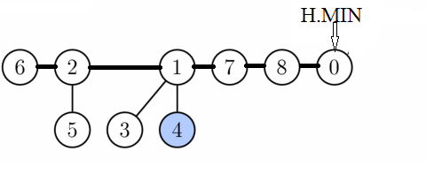
- Given a weighted directed graph G=(V,E) with source s and weight function W:E→R, then write an algorithm to solve a single source shortest path problem whose complexity is O(VE). Apply the same on the following graph with source S.

